How do I assess standards 3-5 for Intermediate and MS students?
HELP
Helpful, Easy, Legitimate, Purposeful
Meggin DeMoss
Rose Hill Primary and Intermediate

What’s In Your Box? Standard 5

I am holding in my hands a box. My box is big and it holds all the things that I value about physical activity in my life: my health, the enjoyment, the challenge, the self-expression and the social interaction. It has, volleyball courts, walking trails, softball diamonds and swimming pools. My dog jumps in and out because sometimes she likes to sleep.

What is in your box? Think about it. Is your box small, medium or large?

Find a partner, share what’s in your box. Switch and share again.
Pull the group together. Share one thing in your box, one from another persons box.
I try to mingle and listen while they are discussing.

Homework: Have them find a box template on line and copy it, or make one up, or hand one out. Write 6 of the things you thought of on your box and turn it in.

The same concept can be use for Health Related Fitness knowledge. Standard 3

In my box today I have things that will increase my Flexibility.

Standard 4 – in my box I have things that make me a good teammate. A good sport.

Communication Crazy – Standard 4 and 5

Good communication involves both sending and receiving information clearly.
Groups of 8-15 form a circle. One person, the “sender” starts and points to someone “receiver” who is not beside them and says the name of a fruit. Keep pointing at your receiver. That person puts their hand on their head and points at someone else and says a different fruit. (Similar to group juggling.) Repeat the pattern and make eye contact with your receiver.
Have them make a mental note “I send to him, She sends to me.”

Now make a completely new pattern and the category is vegetables. Understanding that listening to what my sender’s vegetable is will help me to be focused.

Now try both categories together. One person starts and points, and sends their fruit, then points and sends their vegetable. Continue and see if it can make it around.

Note: If a group keeps losing patterns, suggest that they speak more loudly and clearly: make stronger eye contact: and most important keep attention on their Receivers after sending them the work to ensure they to it and passed it on.

Debriefing Questions.
What made it hard to keep all the patterns in play at once?
What can we do to be better receivers?
What can we do to b better senders?
How does communicating make us better teammates?
How does it make us better friends?

Challenge Activity.
Trade places with your receiver as you are sending your message.

Assessment ideas- I watch for positive feedback and encouragement. Leadership, cooperation for standard 4.

Asking for help and helping others, respect for self and others, effort for standard 5.

Rights and Responsibility Paper - Standard 4

I use these at the end of the 1st nine weeks. You can do one for each student but I have found it is better if they do it in a small group so there is discussion. I see the kids 3 times a week so we do 2 a day for a week. That way it doesn’t take so long.
The paper is at the end of the document.

Snoopy Strips – Anything you want feed back on.

Have tons of Snoopy strips cut up and in a box. Use them as a quick exit slip. Ask a specific question and they answer it by circling how they feel.

My effort in class today was

I understand the rules to pickle ball

I feel _______________ about my pacer test score.

I felt _______________________ about how my group worked together today.

I can climb the wall from right to left.

I can do 5 or more jump rope tricks.

I get 60 minutes of physical activity a day.

Health Related Fitness Relay

Place cards with Health Related Fitness terms and definitions on the floor, face down. Place blank cards on the floor too.

Make groups of 4. Each group has one die. One team member rolls the die and runs out and picks up the number of cards that show on the die. Team matches up the term with the definition. The next player rolls while the first player returns the blank or duplicate cards. Continue until all teams have completed their task. As teams finish, check their work and challenge them to do an exercise for each area.

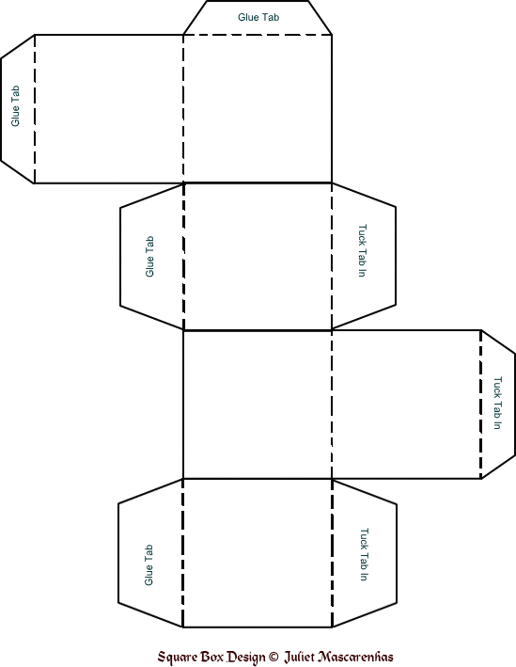

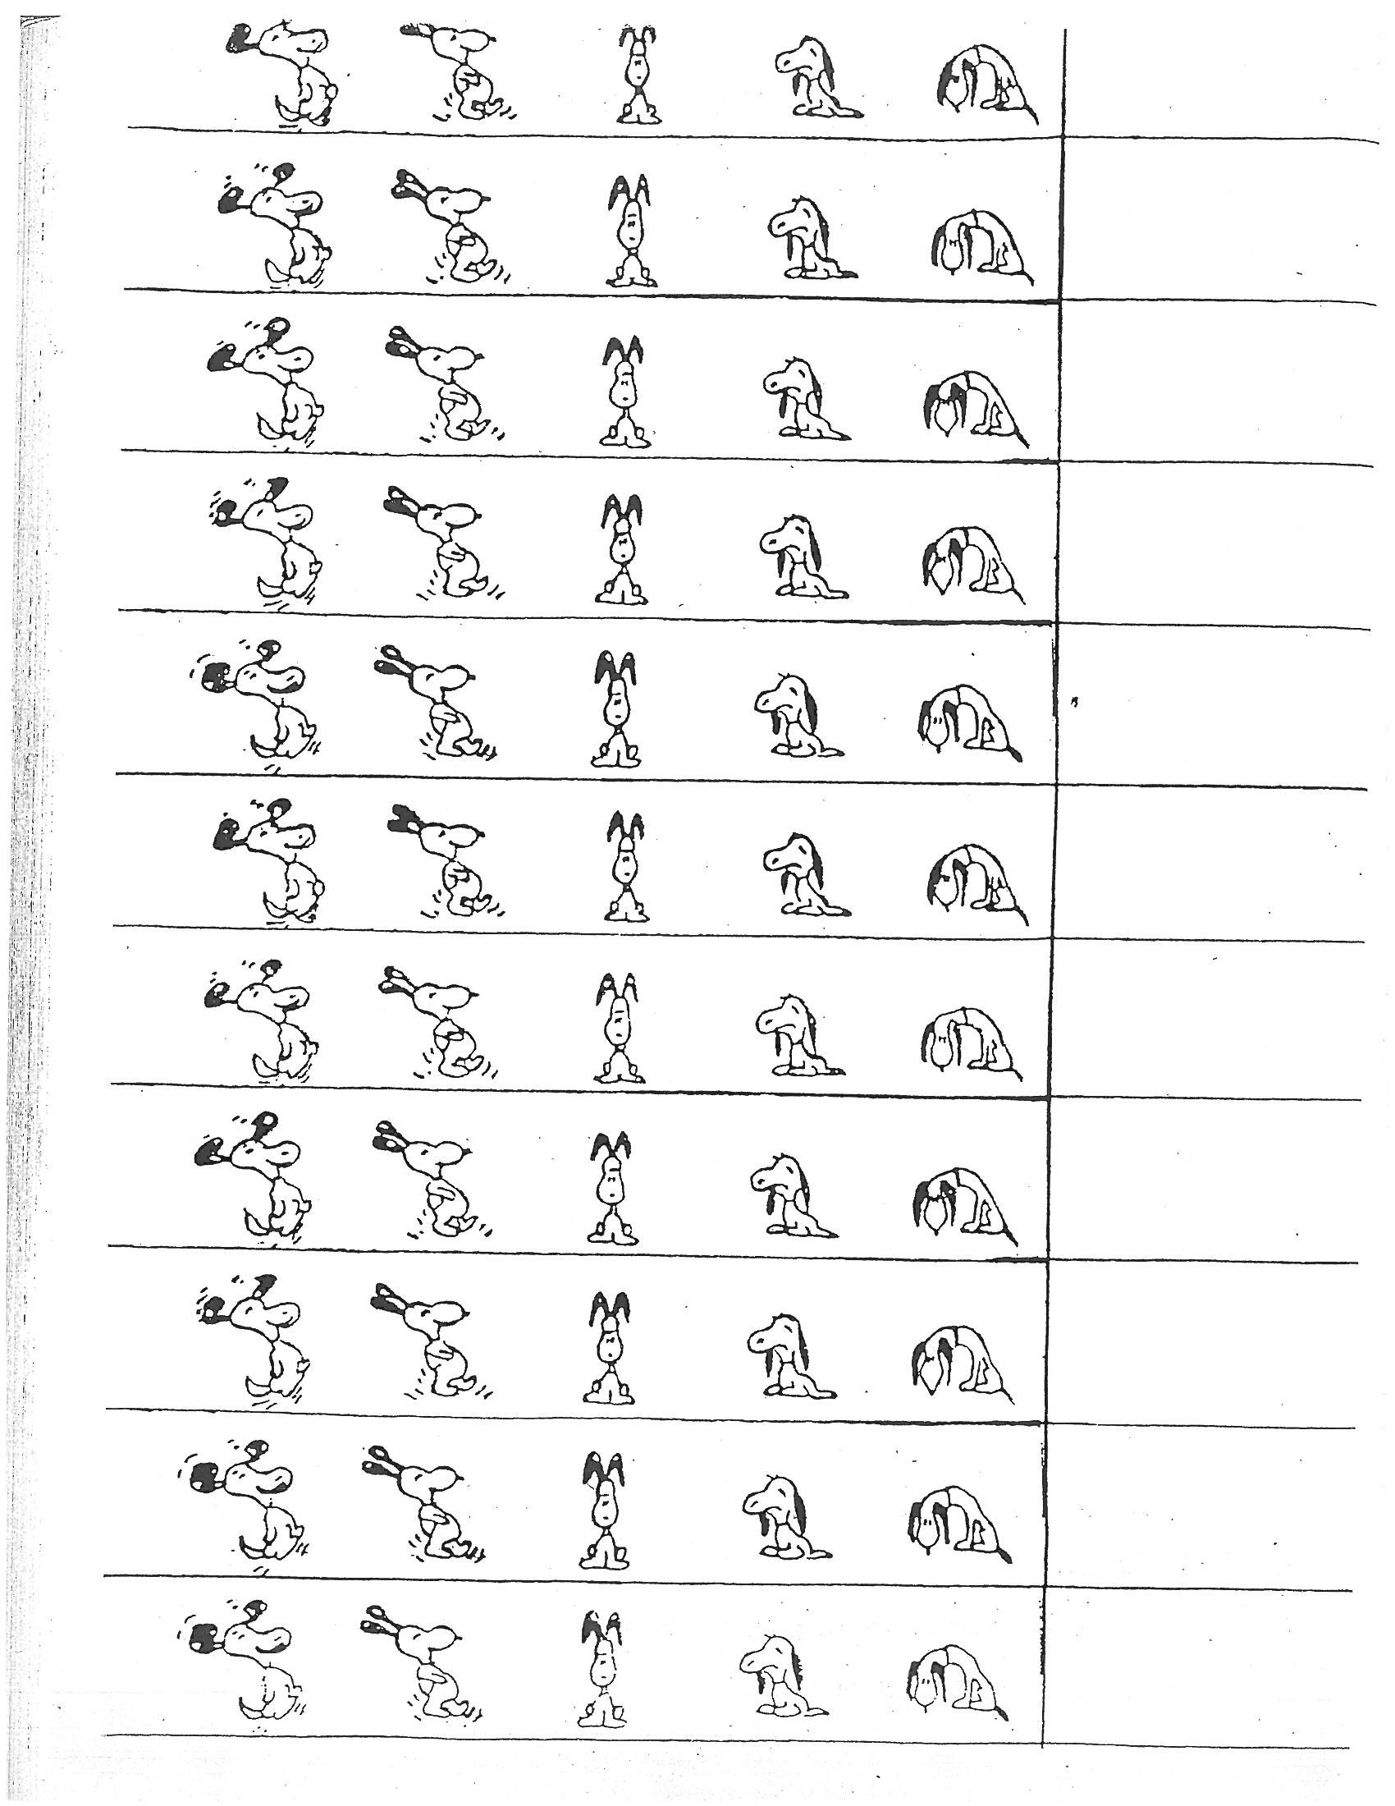

Rights and Responsibilities

I have a right to be treated politely and with respect; therefore
I have a responsibility to ___________________________________________________________________.

I have a right to my own space, equipment and belongings; therefore
I have a responsibility to ___________________________________________________________________.

I have a right to be safe and not hurt by others; therefore
I have a responsibility to ___________________________________________________________________.

I have a right to be treated kindly and fairly; therefore
I have the responsibility to ________________________________________________________________.

I have a right to learn new skills and feel safe trying new activities; therefore
I have the responsibility to ________________________________________________________________.

I have a right to be heard and have people listen to my ideas; therefore
I have a responsibility to __________________________________________________________________________
Fist to Five
What’s Your Number?
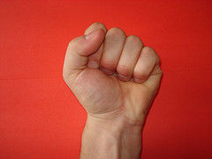  0  I need help.  I don’t understand at all.  I am off task and bothering others. | 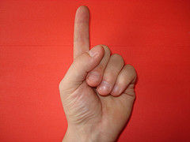  1  I can do this with help or an example in front of me.  I am off task. | 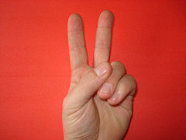  2  I can do this on my own.  I am on task but bothering others. | 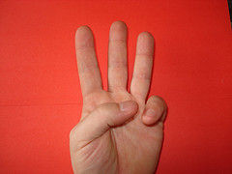  3  I can do it and explain how I did it.  I am on task most of the time. | 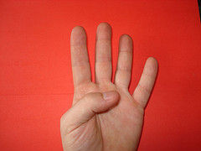  4  I can teach others how to do it.  I am on task all the time. | 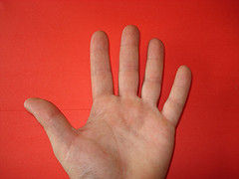  5  I am being a leader and helping others.
Cardiorespiratory Muscular
Endurance Endurance

Is the ability of the heart and lungs is the ability to contract a
to supply oxygen to the working muscle or group of muscles
muscles for an extended period of time. Repeatedly without getting
tired.

Muscular Body Composition
Strength

Is a measure of the greatest is the ratio of lean muscle
force that can be produced by mass (bones, muscles,
a muscle or group of muscles. organs, and water) to fat.

Flexibility

Is the ability of a joint to move
freely in al directions and
through a full range fo motion.

