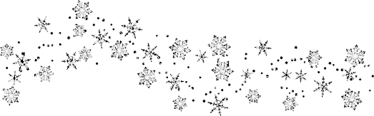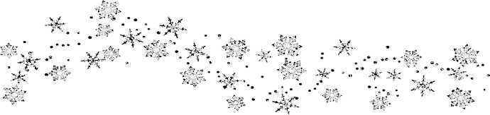**Total Nonstop Action (TNA) with Fitness and Nutrition Concepts  
*KAHPERD K-12 Winter Workshop February 15, 2017 9:00-2:30pm Emporia State University***

***Alex O’Brein  
A highly enthusiastic Trainer for Focused Fitness***

**Alex O’Brien** has his Master’s in Education. His research focused on academic content integrated into physical movement, comparing how they can affect short and long term retention. As a PE teacher, he was instrumental in incorporating technology, social media, and video into PE District wide. Alex leads workshops coast to coast and has presented at the state & national level. Alex is a Trainer for Focused Fitness, and Director of film & Social Media.

Follow him on Twitter. @AlexOBrien

The **focus** of this year’s **KAHPERD Winter Workshop** is to **combine movement activities** with **content knowledge** in order to **stay healthy**, **fit**, and **active** for a lifetime. Developing well-rounded education for K-12 students is essential as they move through our physical education programs.

Alex will offer many practical ideas and showcase K-12 Physical Education best practices including:   
 **Classroom Management   
 Circuit Training  
 Motor Skill Development  
 Social/Emotional Development   
 Instance Activities  
 Health and Fitness Content Integrated  
 through movement**

This professional development will provide multiple opportunities for K-12 teachers to share movement-based activities to move students to a lifetime of physical literacy.

The **outcome** is providing students with the fundamental understanding of how to be healthy, fit, and active for a lifetime.

Participants will walk away with ideas and resources to integrate:  
 **nutrition  
 fitness  
 overall wellness into daily activity**   
**Emporia State University** will offer **one hour** of **Graduate Credit**. **Early** **Bird Registration (Feb10, 2017)**

$40 for members optional $2 ESU parking

$15 for Students & Retirees optional ESU $2 parking

At workshop: After Early Bird Registration, all fees increase by $15

Visit KAHPERD.org website for more information