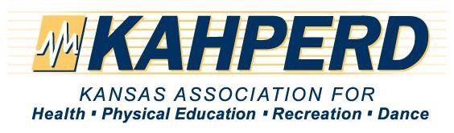

Sponsorship Levels

Annual conference Sponsorship Packages are a great way to leverage your advertising dollars for an extended timeframe. Not only will you receive visibility during the convention, you will gain added exposure in the convention promotions leading up to the event. Select from our pre-packaged Gold, Silver, or Bronze levels, or e-mail the convention manager to customize a package just for you!

Gold Sponsorship $2,500
Your business name or logo prominently displayed in advertisements including:
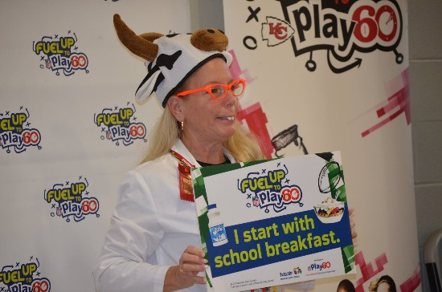
• Your business name or logo on all Convention gifts worn by more than 700 volunteers and participants throughout the convention
• Your business name or logo for Thank You ads in quarterly newsletters and on websites
• Main signage for events sponsored
• 6 VIP reserved passes for Banquet and KAHPERD Convention
• Inclusion in all marketing publications, announcements and emails
• One free, full page ad in two KAHPERD Journals
• One year free link to the KAHPERD website (You will be responsible to provide the information for the ad and space on the website)
• Free booth in the exhibit hall at the annual convention
The Kansas Association for Health, Physical Education, Recreation, & Dance’s 95th Annual Conference will be held in Wichita, Kansas on October 28-30th, 2015. It will be hosted on the Wichita State University campus in the Heskett Center.
Exhibits will be from 7:30am-3:00pm on Thursday, October 29th. Please check our website for more details at: www.kahperd.org
A special discounted hotel rate has been secured at the Drury Plaza Hotel Broadview.
Please make checks out to: KAHPERD and send them to KAHPERD treasurer, Jannelle Robins-Gaede at:
PO Bo 11
Holcomb, KS 67851

• Free insert in the annual convention participants’ packet
• One 50 minute session at the convention, if appropriate
Silver sponsorship $1,000
Your business name or logo prominently displayed in advertisements including:
• Your business name or logo on all Convention gifts worn by more than 700 volunteers and participants throughout the convention
• Your business name or logo for Thank You ads in quarterly newsletters and on websites
• 4 VIP reserved passes for Banquet and KAHPERD Convention
• Inclusion in all marketing publications, website announcements and emails
• One free, full-page ad in one KAHPERD Journal (to be used within one year of the event)
• Six months free link to the KAHPERD website (You will be responsible to provide the information for the ad and space on the website)
• Free booth in the exhibit hall at the annual convention

Bronze sponsorship $500
Your business name or logo displayed in advertisements
• 2 VIP reserved passes for Banquet and KAHPERD Convention
• One free, half-page ad in one KAHPERD Journal (to be used within one year of the event)
• Three months free link on the KAHPERD website (You will be responsible to provide the information for the ad and space on the website)
• Free booth in the exhibit hall at the annual convention

