Wish List Items

Wish List Items are a great way to donate to a specific resource needed to make our convention a success! Not only will you receive visibility during the convention, you will gain added exposure in the convention promotions leading up to the event. Select from our pre-packaged Luncheon, Banquet, or Breakfast Sponsorships, or choose a couple wish lists items that are tailored best to your organization!

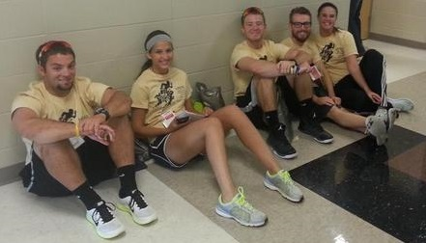
Luncheon Sponsorship $1000
• The luncheon sponsorship would help to feed all of our attendees for Thursday’s lunch
- Your business name or logo would be publicized on our thank-you banner
- Your business name or logo will be publicized in social media efforts leading up to convention
Banquet sponsorship $750
• The banquet sponsorship would help to feed the banquet attendees and those receiving our organization’s annual prestigious awards on Thursday night
- Your business name or logo would be publicized on our thank-you banner
- Your business name or logo will be publicized in social media efforts leading up to convention
Breakfast Sponsorship $500
• The breakfast sponsorship would help to feed all of our attendees for Thursday & Friday’s breakfast snacks
- Your business name or logo would be publicized on our thank-you banner
- Your business name or logo will be publicized in social media efforts leading up to convention

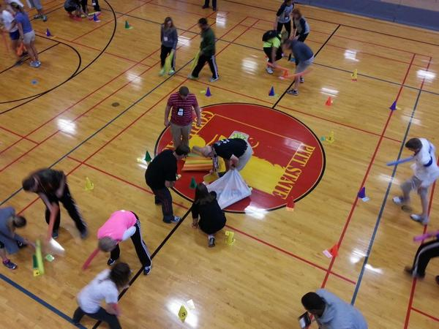

Other Wish List Items

Item Needed | Cost
Future Professional’s Social | $50
Pre-convention networking event | $50
President’s social | $100
Retiree social | $100
After-hour party | $100
Coffee for attendees | $100
Transportation to and from site to parking | $100
Banquet program printing | $100
Nutrition break food items (water, granola, yogurt, etc.) | $100
Flowers for award winners | $150
Soda/pop for snack/refreshment area | $175
Funding for guest speakers | $250
Printing of our program handout (could include your logo!) | $250

